Farmers happy with fishers but not campers on Crown land
by RODNEY WOODS Country News September 20, 2020

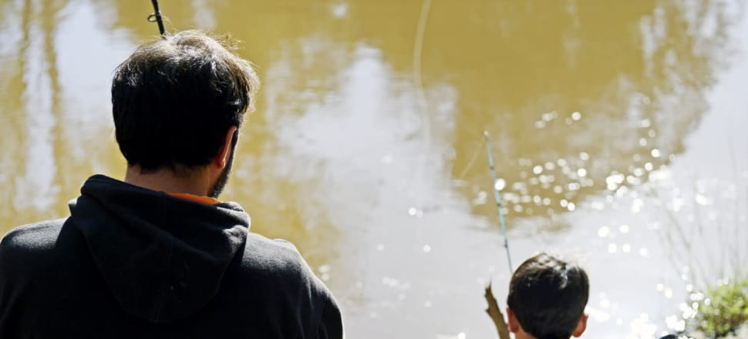
Farmers who lease Crown land are happy with fishers using the land but are not keen on campers who leave gates open or damage the river by dumping rubbish.
Farmers have raised their concerns about camping on Crown land with grazing licences or river frontages, but don't have an issue with those wanting to fish.
The Victorian Government has committed to guarantee access to fishing and camping on Crown land with grazing licences and river frontage, with the improved access coming when the passing of the Parks and Crown Land Legislation Amendment Bill 2019 by the Legislative Council is completed.
As part of the project, the Victorian Fisheries Authority will be installing access gates and signage at the entry points to Crown land.
Fiona Byrnes, who has horses on her Barmah property on the Broken Creek, said her main concern was when campers or duck shooters left gates open, which has seen her horses escape.
“It affects our stock,” she said.
“They're agricultural leases, not just Crown land leases.
“It means you can run stock and if they leave the gates open, the stock get out.
“Sometimes the problem is people don't know where the boundary is to my property.
“Some of it comes to the river and some of the land they are on is Crown land where I have leased and they don't know whether they are on private property or not.
“You probably won’t find too many who lease Crown land that would be against people fishing, if they did the right thing,” Ms Byrnes said.
“We would just like them to come up to the door and ask."
Semi-retired farmer and environmentalist Paul Haw, who lives on the edge of Lake Boort, said the rubbish left by campers was "appalling" in some areas along the Murray River.
“I do a few Aboriginal tours, and after duck season the rubbish and excrement is appalling,” he said.
“If we start a habit of camping on the Loddon (River), they will always do it and we will lose our native grasses and they burn and bury rubbish and it (the damage caused) can destroy the whole ecology of the river system.”

